**GNN 코드 예제**

1. molecular graph로부터 분자의 특성 중 하나인 logP value를 GCN을 통해 예측 <https://github.com/heartcored98/Standalone-DeepLearning/blob/master/Lec9/Lab11_logP_Prediction_with_GCN.ipynb>
2. Graph Neural Networks with Pytorch (모델별 깃허브 코드) <https://github.com/hoopoes/pytorch-gnn-research>
3. Reddit 데이터 세트로 GIN 구현  
   <https://youyoung-jang.medium.com/exploring-pytorch-geometric-with-reddit-data-b38a9a44eec0>

**GNN 사용 라이브러리**

**PyG (PyTorch Geometric)** : GNN을 쉽게 작성하고 훈련하기 위해 PyTorch를 기반으로 구축된 라이브러리 - <https://pytorch-geometric.readthedocs.io/en/latest/>

**DGL (Deep graph library)** - <https://docs.dgl.ai/index.html>

**stellargraph :** GNN

Link prediction : <https://stellargraph.readthedocs.io/en/stable/demos/link-prediction/index.html>

Node classification :

<https://stellargraph.readthedocs.io/en/stable/demos/node-classification/index.html>

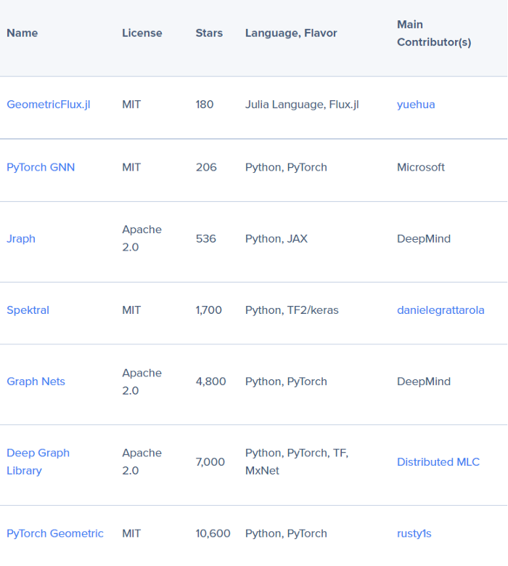

[GNN 라이브러리 비교](https://becominghuman.ai/7-open-source-libraries-for-deep-learning-graphs-7ae294f249d4)

**GNN 유튜브 & 코랩 코드**

**Node Classification on Knowledge Graphs using PyTorch Geometric**

**유튜브 :**

<https://www.youtube.com/watch?v=ex2qllcVneY>

**코드 :**

1. Introduction : <https://colab.research.google.com/drive/1h3-vJGRVloF5zStxL5I0rSy4ZUPNsjy8>

2. Node Classification : <https://colab.research.google.com/drive/14OvFnAXggxB8vM4e8vSURUp1TaKnovzX?usp=sharing#scrollTo=paMH3_7ejSg4>

3. knowledge_graphs_GNN :

<https://colab.research.google.com/drive/1LJir3T6M6Omc2Vn2GV2cDW_GV2YfI53_?usp=sharing#scrollTo=i4WcGtt1SP88>

**Graph Neural Networks (GNN) using Pytorch Geometric | Stanford University**

**유튜브 :**

<https://www.youtube.com/watch?v=-UjytpbqX4A>

**코드 : ->** *돌아가다가 멈춤*

<https://colab.research.google.com/drive/1DIQm9rOx2mT1bZETEeVUThxcrP1RKqAn#scrollTo=3M3Ckk-xEvXm>

**GNN 참고할만한 영상**

GNN :

[개념.002 Graph Neural Network (GNN).01](https://www.youtube.com/watch?v=fMC86a6b5oM)

Graph-Based Semi-Supervised Learning :

<https://www.youtube.com/watch?v=Nn9fX5C0rrY>

GAT :

<http://dmqm.korea.ac.kr/activity/seminar/296>

XAI :

[[Paper Review] GNNExplainer: Generating Explanations for Graph Neural Networks](https://www.youtube.com/watch?v=PrNwfNOge8o)